Black Sea from Space Workshop

Jointly organised by ESA, ROSA and the National Institute for Marine Research and Development “Grigore Antipa”

28-30 September, 2016

Hotel Flora
Constanta, Romania

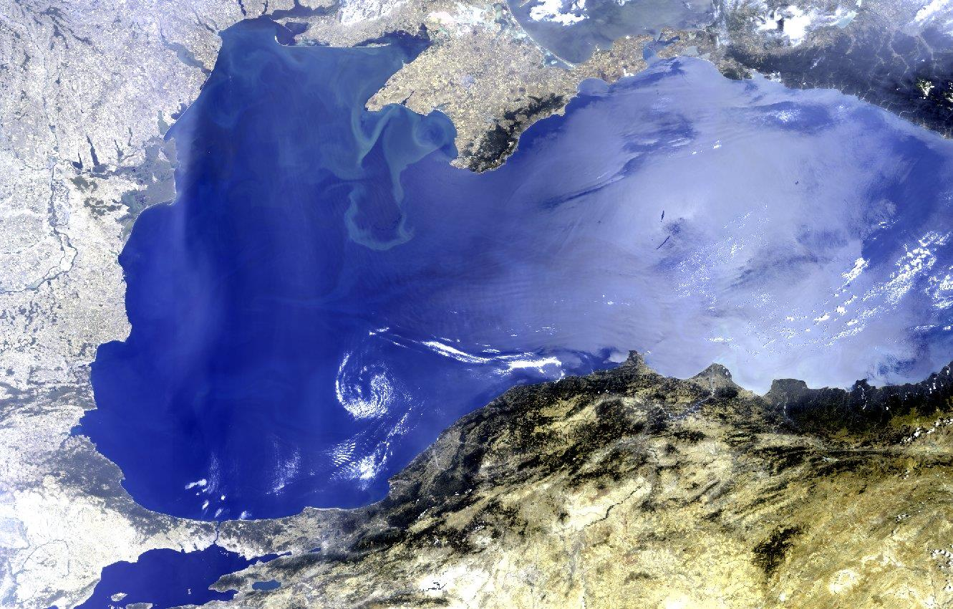

BACKGROUND

The Black Sea region represents a high priority in the political arena, characterised by an emerging dynamic economic growth and affected by important environmental transformations and climate impacts that require continuous monitoring and assessment.

Since the early 1970s, the Black Sea has been affected by significant ecological alterations, essentially caused by anthropogenic factors. Dam constructions on the Danube River in combination with heavy nutrients discharge via the riverine runoff result in large alterations of its physical and biogeochemical properties, ultimately leading to an enhancement of the typical anoxic state of the deep waters. The Black Sea area has undergone significant transformations that caused important ecosystem changes (eutrophication, impacts on ﬁsh stock, alien species invasion), pollution that
affects water quality (especially in an almost closed sea), coastal erosion and impacts by global climatic processes such as the Atlantic Multidecadal Oscillation (AMO) and North Atlantic Oscillation (NAO).

In this context, Earth Observation (EO) represents an opportunity for innovative science, applications and information services to face some of these issues as well as a potential catalyser for innovation
and growth in the region.

Nowadays, we are entering a new era for EO science and applications driven by the continuously increasing observation capacity offered by the Sentinel missions, the opportunities for science offered by the Earth Explorer series and the capabilities to look at the past offered by the existing long-term EO data archives. To maximize the full exploitation of this unprecedented ability of spaceborne Earth monitoring by the scientific community, industry and the public sector, dedicated research and development efforts are required.

The focus of this workshop is to assess the opportunities for EO research and development activities in the Black Sea Basin and the Danube Delta region that may be the basis for future ESA investments in terms of science, development of novel applications and testing new information services to address some of the key information needs of this important area.

OBJECTIVES

1. To review the main requirements from geo-information in the Black Sea and Danube Delta region from science to information services;
2. To review the main activities, projects and initiatives taking place in the region where EO may contribute;
3. To assess the potential of the increasing observation capacity offered by satellites to address the needs for science, applications and future information services;
4. Discuss and agree on a number of key priority areas and requirements for research and development activities that may address the science and applications needs of a wide range of user sectors in the regions.

The main output of the project will be a Workshop Report summarising the key findings and recommendations for dedicated scientific activities, applications development and service innovation for a wide spectrum of users (scientific, institutional, private sector, international bodies) in this area.
This report will support ESA in defining future investments in EO research and development activities to foster EO innovation in the region.

PRELIMINARY LIST OF RELEVANT TOPICS

▪ Science:
o Ocean Science
o Land-ocean interactions
o Biodiversity, ecology and ecosystems
o Hydrology
o Water Cycle
o Carbon cycle
o Extremes (e.g., heat waves, draughts, floods)
o Climate Impacts

▪ Applications:
o Pollution
o Oil spills
o Water quality
o Water management
o Coastal degradation/erosion and shorelines monitoring
o Marine monitoring/Operational oceanography
o Flooding
o Air quality
o Fisheries
o Wetland monitoring
o Ecosystem monitoring
o Urban impacts on coastal zones

▪ Cooperation:
o Establish monitoring priorities
o Implement international cooperation and initiatives
o Regional implications of the environmental changes
o Improvement of monitoring abilities of the Black Sea Basin and the Danube Delta region
o Big data analytic capabilities

ORGANISATION
▪ The workshop is organised around oral and poster presentations.
▪ Sessions will be designed around dedicated topics related to the workshop’s objectives.
▪ Presenters of both oral and poster presentations are required to submit abstracts, 200-250 words.
▪ The official language of the workshop is English.
▪ No participation/registration fee will be charged.
▪ Participants are expected to finance their own travel and accommodation expenses.
ORGANIZING COMMITTEE
Alexandru Badea (ROSA)
Gordon Campbell (ESA)
Iulia Dana (ROSA)
Diego Fernández Prieto (ESA)
Mariana Golumbeanu (National Institute for Marine Research and Development “Grigore Antipa”)
Razvan Mateescu (National Institute for Marine Research and Development “Grigore Antipa”)
Ion Nedelcu (ROSA)
Simion Nicolaev (National Institute for Marine Research and Development “Grigore Antipa”)
Magda Nenciu (National Institute for Marine Research and Development “Grigore Antipa”)
Cristina Surdu (ESA)
Tania Zaharia (National Institute for Marine Research and Development “Grigore Antipa”)
Laura Alexandrov (National Institute for Marine Research and Development “Grigore Antipa”)

DEADLINES
Abstract Submission: 15 June 2016
Notification of acceptance and preliminary programme: July 2016
Registration: September 2016

CONTACT
ESRIN Events Organisation
e-mail: events.organisation@esa.int
Tel. : +39 06 9418 0912
Fax.: +39 06 9418 0902

